Short English course
for
seller (level 3) verkoper groene detailhandel
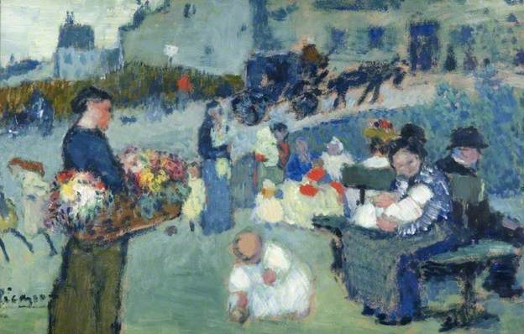
Stop selling.
Start helping.
- Stock – order – purchase
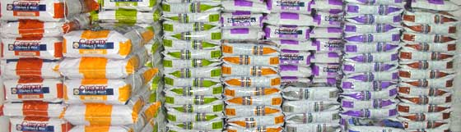
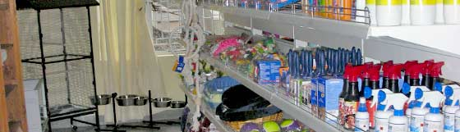
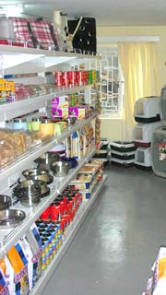

Trade is not about goods. Trade is about information. Goods sit in the warehouse until information moves them.
- Watch the film
Modernizing Inventory Management
Answer the next questions .(Dutch)
- Where is this store situated?
- What is the customer looking for?
- Is the article on stock or not?
- What is the seller doing?
- What is the name of the store?
- When did the sun take over?
- In which year did the father start the business?
- What is the name of the father?
- What is ythe different approach of the sun?
- How many different items are available?
- How many stores are there nowadays?
- What is helpful in keeping track on all items in the stores?
- What is meant by the IT is not a cost but a spend?
- What is the latest pend in IT.

2. The Purchasing Process
Why is it important to have a formal purchasing process? Is it important to have a predefined purchasing process? What can go wrong if the purchasing process is not followed?
There are many reasons why a formal process must be followed including the prevention of fraud, cost saving, compliance with regulations, management of risk and control. To understand or to explain why a formal process should be followed it can be useful to think in terms of the 5 As.
- Approved Suppliers
- Approval Process and Segregation of Responsibilities
- Audit Trail
- Accounting
- Automation
There is sometimes a significant amount of effort required to ensure that a supplier is appropriate for a particular category of goods or services. They should be able to supply goods and services that meet requirements of quality and fit for purpose. They should be reliable financially sound and not present a commercial or reputation risk and their prices should be competitive. It makes no sense to perform the relevant research on a supplier each time goods or services are required. By developing preferred suppliers, longer term sustainable relationships can be developed that deliver a better value for money.

Approval Process and Segregation of Responsibilities
- The principles of approval and segregation of responsibilities provides an organization with a control to reduce the risk of fraud. The requirement for the approval of a purchase requisition prevents inappropriate purchases being made and the separation of responsibilities to unconnected parts of the buying organization helps to reduce the risk of collusion.

Audit Trail
- A formal purchasing process that records a predefined set of processes allows the path of events to be examined retrospectively to identify errors or deliberate breaches of policy.

Accounting
- All commercial organizations have a legal responsibility to account for their finances including for the goods and services that they procure. It is important therefore that proper records are maintained e.g. to record dates, prices and department details as well as to categorize goods and services appropriately to distinguish between capital goods and expenses for example. This can have a crucial bearing on how the finances of the organisation are described which in turn can have a tax and profitability impact.

Automation
- A standard process allows for automation and the use of technology which reduces the cost of the process.

approve | goedkeuren
PO (purchase order) | koopopdracht (order)
request | verzoek
fulfilment | uitvoering
GRNI (Goods Received Not Invoiced) | niet gefactureerde wel geleverde goederen
Accrual | tegenrekening voor ontvangen nog niet gefactureerde goederen
audit trail | controle traject
purchase | aankoop, inkoop
suppliers | leveranciers
appropriate | geschikt
Meet | overeenkomen
requirements | eisen
purpose | doel, opzet
Reliable | betrouwbaar
Sound | gezond
preferred | gewenst
sustainable | duurzame
value for money | waar voor je geld
segregation | scheiding
collusion | heimelijke afspraken
unconnected parts | dingen die eigen leven gaan leiden
retrospectively | terugkijkend
deliberate | opzettelijk
to breach | inbreuk maken
Policy | beleid
to procure | verwerken
to distinguish | onderscheiden
capital goods | investeringen
expenses | uitgaven, kosten
Bearing | invloed

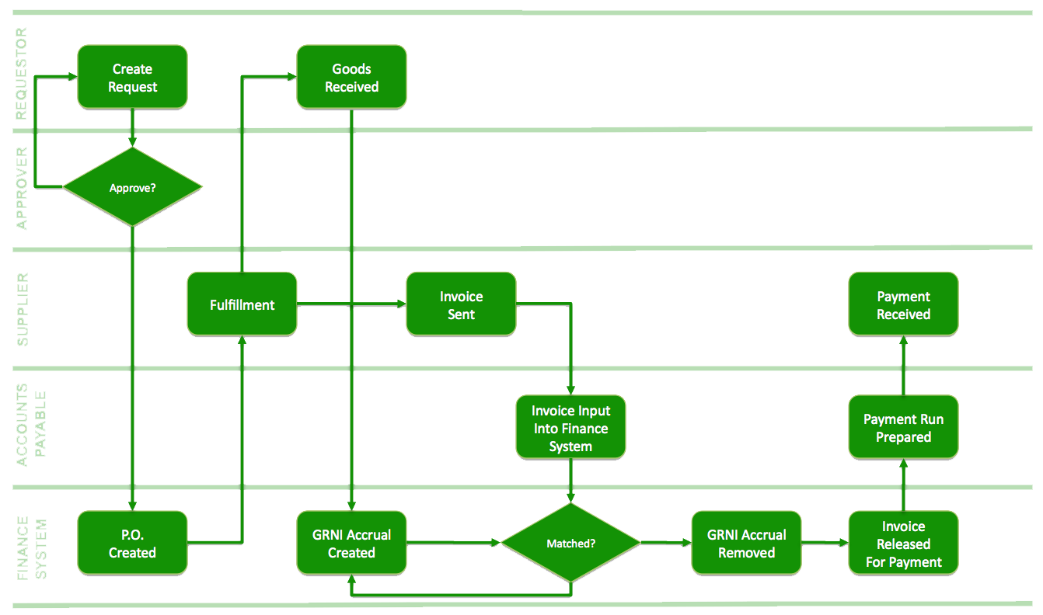

- Dialogue
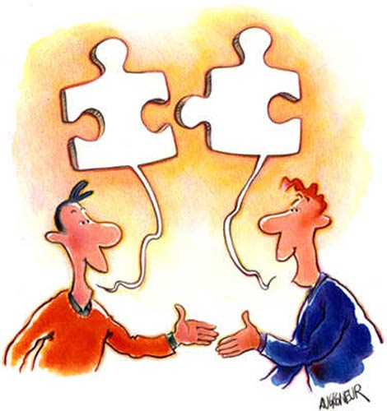
Write down at least 10 questions to ask your partner about the article above. Write down the given answers. Afterwards discuss the answers. In English please.
Avoid closed questions (yes or no). Use: why, when, who, what, where….

- 50 BASIC ENGLISH QUESTIONS (practice with your partner)
Here are 50 basic (American) English questions with responses.
Personal Information
What's your name? | Peter.
Where are you from? / Where do you come from? | I'm from ... I come from ...
What's your surname / family name? | Smith.
What's your first name? | Tom.
What's your address? | 7865 NW Sweet Street
Where do you live? | I live in San Diego.
What's your (tele)phone number? | 209-786-9845
How old are you? | Twenty-five. I'm twenty-five years old.
When / Where were you born? | I was born in 1961 / Seattle.
Are you married? / What's your marital status? | I'm single.
What do you do? / What's your job? | I'm a florist.
Where did you go? | I went to a friend's house.
What did you do? | We worked in the garden.
Where were you? | I was in New York for the weekend.
Have you got a car / job / house / etc.? | Yes, I've got a good job.
Have you got any children / friends / books / etc.? | Yes, I've got three children - two boys and a daughter.
Can you play tennis / golf / football / etc.? | Yes, I can play golf.
Can you speak English / French / Japanese / etc.? | No, I can't speak Japanese.
Could you speak English / French / Japanese / etc. when you were five / two / fifteen / etc. years old? | Yes, I could speak English when I was five years old.
Introducing Yourself / Saying Hello
How do you do? | How do you do. Pleased to meet you.
How are you? | Fine, thanks. And you?
Shopping
How can I help you? / May I help you? | Yes. I'm looking for a sweater.
Can I try it on? | Sure, the changing rooms are over there.
How much does it cost? / How much is it? | It's $45.
How would you like to pay? | By credit card.
Can I pay by credit card / check / debit card? | Certainly. We accept all major cards.
Have you got something bigger / smaller / lighter / etc.? | Certainly, we've got smaller sizes as well.
Asking Something Specific
What's that? | It's a cat!
What time is it? | It's three o'clock.
Can / May I open the window? | Certainly. It's hot in here!
Is there a bank / supermarket / pharmacy / etc. near here? | Yes. There is a bank on the next corner next to the post office.
Where is the nearest bank / supermarket / pharmacy / etc.? | The nearest pharmacy is on 15th street.
Who wrote / invented / painted / etc. the ...? | Hemingway wrote "The Sun Also Rises".
Is there any water / sugar / rice / etc.? | Yes, there's a lot of sugar left.
Are there any apples / sandwiches / books / etc.? | No, there aren't any apples left.
Is this your / his / her / etc. book / ball / house / etc.? | No, I think it's his ball.
Whose is this / that? | It's Jack's.
Questions with 'Like'
What do you like? | I like playing tennis, reading and listening to music.
What does he look like? | He's tall and slim.
What would you like? | I'd like a steak and chips.
What is it like? | It's an interesting country.
What's the weather like? | It's raining at the moment.
Would you like some coffee / tea / food? | Yes, thank you. I'd like some coffee.
Would you like something to drink / eat? | Thank you. Could I have a cup of tea?
Asking for an Opinion
What's it about? | It's about a young boy who encounters adventures.
What do you think about your job / that book / Tim / etc.? | I thought the book was very interesting.
How big / far / difficult / easy is it? | The test was very difficult!
How big / far / difficult / easy are they? | The questions were very easy.
How was it? | It was very interesting.
What are you going to do tomorrow / this evening / next week / etc.? | I'm going to visit some friends next weekend.
Suggestions
What shall we do this evening? | Let's go see a film.
Why don't we go out / play tennis / visit friends / etc. this evening? | Yes, that sounds like a good idea.

Falling down is how we grow. Staying down is how we die.
6. P.O. Make this form in Excel and make it work; look for a colleague to assist; discuss in English.
[Company Name] |  |  |  | PURCHASE ORDER
[Company Slogan] |  |  |  |  |  |  |  | DATE: |  | 28-12-2012
 |  |  |  |  |  |  |  | P.O. # |  | [123456]
[Street Address]
[City, ST ZIP]
Phone: [000-000-0000]
Fax: [000-000-0000]
VENDOR |  |  |  | SHIP TO
[Name] |  |  |  | [Attn: Name]
[Company Name] |  |  |  | [Company Name]
[Street Address] |  |  |  | [Street Address]
[City, ST ZIP] |  |  |  | [City, ST ZIP]
[Phone] |  |  |  | [Phone]
REQUISITIONER | SHIP VIA |  |  | F.O.B. | SHIPPING TERMS
ITEM # | DESCRIPTION |  |  |  | QTY |  | UNIT PRICE |  | TOTAL
[23423423] | Product XYZ |  |  |  | 15 |  | 150,00 |  | 2.250,00
[45645645] | Product ABC |  |  |  | 1 |  | 75,00 |  | 75,00
 |  |  |  |  |  |  |  |  | -
 |  |  |  |  |  |  |  |  | -
 |  |  |  |  |  |  |  |  | -
 |  |  |  |  |  |  |  |  | -
 |  |  |  |  |  |  |  |  | -
 |  |  |  |  |  |  |  |  | -
 |  |  |  |  |  |  |  |  | -
 |  |  |  |  |  |  |  |  | -
 |  |  |  |  | [42] |  | SUBTOTAL |  | $ 2.325,00
Other Comments or Special Instructions |  |  |  |  |  |  | TAX RATE |  | 6,875%
 |  |  |  |  |  |  | TAX |  | $ 159,84
 |  |  |  |  |  |  | S & H |  | $ -
 |  |  |  |  |  |  | OTHER |  | $ -
 |  |  |  |  |  |  | TOTAL |  | $ 2.484,84
Authorized by |  |  |  | Date
If you have any questions about this purchase order, please contact
[Name, Phone #, E-mail, Phone, Fax]
- Advertisement and promotion

Doing business without advertising is like winking at a girl in the dark. You know what you are doing but nobody else does.

- Watch the film PR 2.0?
Match the remarks with the cartoons from the film (Put the numbers in de cells)
- Something that has never done before
- This product is great
- Businessman has a great idea to produce a product
- title
- on line relation building
- to tackle the mystery of social media
- the right vehicle
- the right message to the right audience

- Presentation
Watch the film again and open the PowerPoint slide show PR2.0. Rehearse with a partner how you can tell the PR story to him/her.
- Advertising vs Promotion
Advertising is a one-way communication whose purpose is to inform potential customers about products and services and how to obtain them. Promotion involves disseminating information about a product, product line, brand, or company. It is one of the four key aspects of the marketing mix. Advertising may be one form of promotion.
 | Advertising | Promotion
Time: | Long term | Short term
Price: | Expensive in most cases | Not very expensive in most cases.
Suitable for: | Medium to large companies | Small to large companies
Sales: | Assumption that it will lead to sales | Directly related to sales.
Example: | Giving an advertisement in the newspaper about the major products of a company | Giving free products, coupons etc.
About: | A type of marketing tool | A type of marketing tool
Definition: | Advertising is a one-way communication whose purpose is to inform potential customers about products and services and how to obtain them. | A Promotion usually involves an immediate incentive for a buyer (intermediate distributor or end consumer). It can also involve disseminating information about a product, product line, brand, or company.
Purpose: | Increase sales, brand building. | Increase sales.
Result: | Slowly | very Soon

Differences in Timeframe
Promotions are time specific and may be short term while Advertising may be generically long term. For example: ABS company may start a promotion of giving free drinks at a mall for a day during the festive season, while the same company may advertise much before about their drink at the start of the festive season and extend it during and beyond the season. Advertising is aimed towards the long term building of the brand while Promotion is aimed at the short term tactical goal of moving ahead in sales.

Types of promotion and advertising
Promotion is generally divided in two parts:
- Above the line promotion: Promotion in the media.
- Below the line promotion: All other promotion. Much of this is intended to be subtle enough that the consumer is unaware that promotion is taking place. E.g. sponsorship, product placement, endorsements, sales promotion, merchandising, direct mail, personal selling, public relations, trade shows.
Advertising can be of the following types:
- Media: Commercial advertising media can include wall paintings, billboards, street furniture components, printed flyers and rack cards, radio, cinema and television ads, web banners, mobile telephone screens, shopping carts, web popups, skywriting, bus stop benches etc.
- Covert Advertising: Covert advertising is when a product or brand is embedded in entertainment and media. For example: John Travolta wearing only "Diesel" clothing in a movie.
- Television Commercials: Virtual advertisements may be inserted into regular television programming through computer graphics. It is typically inserted into otherwise blank backdrops.
- Internet Advertising: This is the newest form of advertising wherein web space is used and email advertising is used.

Relationship of Sales with advertising and promotions
Typically promotions are directly linked with sales while advertising is an assumption that it may lead to sales. For example: Giving 20% discount on products may attract a customer and induce instant sale while giving a general brand creation advertisement in the newspaper may not induce immediate sale.

Cost of advertising vs promotion
Promotions are directly linked to sales and hence for small companies it may be easier to use promotional methods. Advertising may be more expensive for small companies and it may not be feasible for them while in advertising it is being assumed that adverts will lead to sales.
For example: A store may give 20% discount on its products which may increase sales while the same shop may find it difficult to advertise this in various medias.

obtain | verkrijgen
disseminating | verspreiden
assumption | onderstelling
incentive | aansporing
subtle | subtiel
endorsement | goedkeuring
merchandising | verhandelen
covert | verborgen
embedded | ingebed
inserted | geplaatst
induce | veroorzaken
hence | vandaar
feasible | uitvoerbaar

Answer the next questions.(Dutch)
  - In the table you see a comparison between advertising and promotion; what is similar?
  - Which is directly related to sales?
  - Which is more feasible for large companies?
  - Give an example of covert advertising?
  - Can you describe what above the line promotion is?
  - And what is virtual promotion?
  - Mention 5 sorts of media for commercial advertising.
  - Do you think promotion is at the tactical or strategic level?
  - Which form is mostly used for brand building?
  - Mention 3 everyday examples of promotion.

- Make an ad(vertisement)
- Check, recheck and check your ad copy again.
- If possible, and if you know how, use the golden ratio for your advertisement design.
- Ads cost a lot of money, and a good ad takes your dollar a long way. It might be worth paying a professional copywriter for a great ad.
- Less is always more. The less a reader has to read, the less a listener has to take in, bodes well for your ad.

Tips

Designing an Advertisement
- 1
Choose a memorable image. Simple but unexpected is often the best route to take. For example, these stark, colorful silhouette ads that barely even show the iPods they’re peddling couldn’t get much more straightforward, but because they don’t look like any other ads, they are instantly recognizable.
Distinguish yourself from your top competitor(s). A burger is a burger is a burger, but if you let yourself think like that, you’ll never make your sale. Use your ad to highlight your product’s advantages over that of your competitors. To avoid lawsuits, keep to statements about your product, not theirs. For example, this Burger King ad mocks the size of the Big Mac while speaking the literal truth: that is a Big Mac box, after all, leaving McDonalds no legal ground from which to retaliate.
3
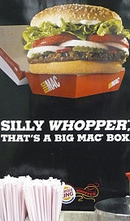
Design a business logo (optional). A picture says a thousand words, and if a logo is effective enough, it can render text unnecessary (the backwards Nike checkmark, the Apple bitten apple, the McDonalds arches, the Chevron shell). If you're running a print or television advertisement, try to develop a simple, appealing image that will stick in the minds of viewers. Consider these points: Do you already have a logo? If you can, think of fresh and creative ways of re-imagining it.
Do you have a commonly-used color scheme to work with? If your brand is instantly recognizable by the colors in the ad or the logo, use this to your advantage. McDonalds, Google, and Coca-Cola are good examples.

Find a software or technique creating your advertisement. How you create your ad will depend on which medium you're using to advertise. Here are some basic suggestions to get you started: If you're making a small-scale print ad (such as a flyer or magazine advertisement), try using a program such as Adobe InDesign or Photoshop. Or, if you're looking for a free option, you can use GIMP or Pixlr.
  - If you're making a video ad, try working with iMovie, Picasa, or Windows Media Player.
For an audio ad, you can work with Audacity or iTunes.
For a large-scale print ad (such as a banner or billboard), you'll probably have to contact a print shop to get the work done. Ask which software they recommend using.

C. Pricing
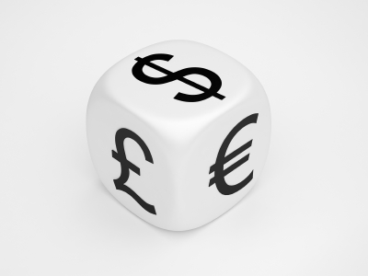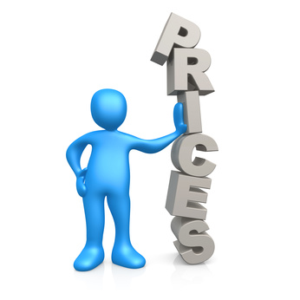
If the other fellow sells cheaper than you, it is called dumping. 'Course, if you sell cheaper than him, that's mass production.’
  - Cost-based Pricing
Each of the three cost-based pricing methods described begin with a product cost subtotal. To calculate product cost you need to include the costs of operating the business, which could include raw materials, transportation, advertising, wages, rent and other costs incurred in producing the product. Once you have a base cost, then add the profit level you want for the business to the product cost subtotal to determine your product price. The amount of profit you add to the product cost subtotal can be set according to the following three different methods:
- include a profit percentage with product cost (mark-up pricing)
- add a percentage to an unknown product cost (cost-plus pricing)
- price is a blend of total profit and product cost (planned-profit pricing

All types of cost-based pricing will be more accurate if you use a complete product cost subtotal. The key to accuracy is to ensure all cash and non-cash costs (raw material, labour and overhead/operating costs) are included in the product cost subtotal. You need to set a value for your management expertise and labour. The use of your land or capital equipment also must be valued along with depreciation on your machinery and buildings. These values are included in the product cost subtotal.
Include a profit percentage with product cost
Marketers call this method mark-up pricing. Mark-up pricing is favoured by businesses with many products because it is simple to calculate. The profit level you want for the business is expressed in a percentage. This percentage is added to the production cost to set product price. Mark-up pricing is common in retail business because of so many types of products and purchases from many vendors.
Example:
Wild Blue Preserves makes 15 different jams and jellies. They set up a small shop in a local mall to sell their products alongside other prepared foods. A jar of wild blueberry jelly costs $1.50 per 250 ml jar to produce. The mark-up pricing percentage Wild Blue Preserves plans to use is 40 per cent. The jar of jam will cost $ 2.10 in the shop.
Add a percentage to an unknown product cost
This type of pricing is often called cost-plus pricing. Cost-plus pricing works well if you do not know your production costs. This method is very similar to mark-up pricing. The big difference between mark-up pricing and cost-plus pricing is that both buyer and seller settle on the profit figure or percentage, accepting that the cost of production is an unknown. If you produce custom order products for other firms or individuals, a cost-plus pricing method could reduce your risk. Rather than take a risk on input costs increasing during the project, you could use a cost-plus pricing agreement.
Example:
You have agreed to act as a co-packer for a start-up snack food business, packaging and distributing low-fat energy bars. As a co-packer, you will purchase ingredients through your suppliers, but you are unsure of input costs. The snack food business signs a contract with you to pay for materials costs plus a processing cost of $25 per case.
Price is a blend of total profit and product cost
Otherwise known as planned profit pricing, this method ensures you will earn a total profit for the business. It differs from the first two types of cost-based pricing as they focused on a per unit price. Planned profit pricing combines per unit costs with output projections to calculate product price. Break-even analysis is used to calculate planned profit pricing. Planned profit pricing is well suited to manufacturing businesses. A manufacturer often has the ability to increase or lower production depending upon the demand or profit available.
Example
A special order cake business could set prices according to the size of the orders they receive from various customers. A price break is given to customers who order 10 or more cakes at a time.
The main advantage of planned profit pricing is that it allows the manufacturer to consider how various levels of output can affect the product price. As well, the manufacturer can examine how various prices will affect the amount of output needed.
Disadvantages of cost-based pricing
Before you select a cost-based pricing option, you should consider the disadvantages. There are two important reasons why cost-based pricing doesn’t work for some businesses:
Cost-based pricing does not consider how customer demand affects price. Demand for a product will directly affect how much people will pay. If, due to heavy demand, customers believe a product is in short supply, they may be willing to pay more. On the other hand, if demand is very low the customer will look for a discount on the price.
Competition is not included in cost-based pricing methods. Competition should affect how you price your product. The idea of simply adding a profit level or percentage to a product price will only work in industries with limited competition. In a competitive market, cost-based pricing may encourage competitors to enter the market with a lower price.
Answer the next questions (in Dutch)
- Which three pricing methods are mentioned in this article?
- What does the author mean with cost subtotal’?
- What are non-cash costs?
- What method is simple to calculate?
- What is the difference between mark-up pricing and cost plus pricing?
- What is the principle of planned profit pricing?
- What is a break-even analysis?
- Mention two disadvantages of cost based pricing.
- When is a customer looking for a discount?
- In what kind of market cost based pricing is not working?

  - Pricing

June's Furniture Price Schedule by Margins
item | wholesale cost | selling price = cost/(1-markup on selling price) |  |  | profit on 50% | profit on 55% | profit on 60%
 |  | 50% | 55% | 60%
sofa | 275,00 | 550,00 | 611,11 | 687,50 | 275,00 | 336,11 | 412,50
lamp | 125,00 | 250,00 | 277,78 | 312,50 | 125,00 | 152,78 | 187,50
end table | 225,00 | 450,00 | 500,00 | 562,50 | 225,00 | 275,00 | 337,50
chair | 215,00 | 430,00 | 477,78 | 537,50 | 215,00 | 262,78 | 322,50
rug | 425,00 | 850,00 | 944,44 | 1.062,50 | 425,00 | 519,44 | 637,50
picture | 100,00 | 200,00 | 222,22 | 250,00 | 100,00 | 122,22 | 150,00
totals | 1.365,00 | 2.730,00 | 3.033,33 | 3.412,50 | 1.365,00 | 1.668,33 | 2.047,50

Discuss with your partner in English how you could realise such a table for price calculation in Excel.
If you need help open the worksheet ´Excel Magic trick 285´.
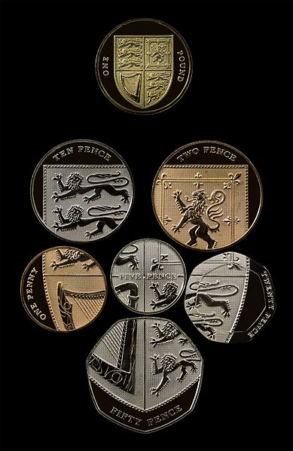
3. The pound sterling (GBP)
All frequently used coins except the £2 coin (coins shown are those after the extensive 2008 redesign).
Penny – pence
Pound - pounds

1 EUR = 0.8 GBP

Coin – coins

Pence (p) | Pounds (£)
1p | £ 1
2p | £ 2
10 p
20p
50p
Banknotes
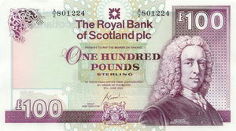 | 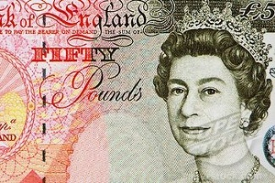 | 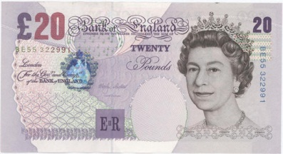
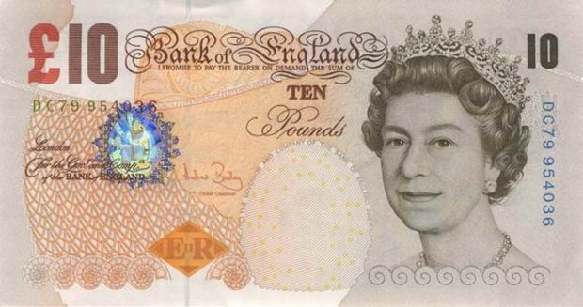 | 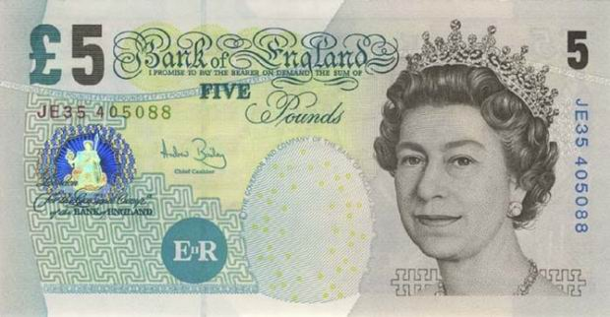

Fill out next form/table.
Return and change
Cost - price | Payd with | Change | ±Value in euro’s
£ 3.75 | £ 5 | £ 1 + 20p+2p+2p+1p | € 4,31
£ 88 | £ 50+£ 50
£ 34 | £ 20+£ 20
£ 26.50 | £ 20+£ 10
£ 1.95 | £ 2
£ 0.65 | £ 1
£ 55 | £ 50+£ 20
£ 73.40 | £ 50+£ 50
£ 0.25 | 50p
£ 6.85 | £ 10

- Work order
Try to realise the order below in Excel. Cooperate with your partner and help each other. Instructions in English please.
Of course you may ask your teacher for help.
There is no example to copy, so you have to do it on your own.
Good Luck!

[Company Name / Logo] |  |  |  | WORK ORDER
 |  |  |  |  | W.O. # : | [123456]
[Street Address] |  |  |  |  | W.O. Date : | 22-12-2010
[City, ST ZIP]
Phone: [000-000-0000] |  |  |  | Requested By : | [Customer Name]
Fax: [000-000-0000] |  |  |  | Customer ID : | [abc1]
[Web Address] |  |  |  | Department :
JOB |  |  | BILL TO |  | SHIP TO (if different)
[Enter description of work] |  |  | [Name] |  | [Name]
 |  |  | [Company Name] |  | [Company Name]
 |  |  | [Street Address] |  | [Street Address]
 |  |  | [City, ST ZIP] |  | [City, ST ZIP]
 |  |  | [Phone] |  | [Phone]
QTY | DESCRIPTION |  |  | TAXED | UNIT PRICE | LINE TOTAL
15 | Part XYZ |  |  | x | 150,00 | 2.250,00
5 | Hourly Labour for ABC (5 hours) |  |  |  | 50,00 | 250,00
 |  |  |  |  |  | -
 |  |  |  |  |  | -
 |  |  |  |  |  | -
 |  |  |  |  |  | -
 |  |  |  |  |  | -
 |  |  |  |  |  | -
 |  |  |  |  |  | -
 |  |  |  |  |  | -
 |  |  |  |  |  | -
 |  |  |  |  |  | -
 |  |  |  | [42] | SUBTOTAL | $ 2.500,00
Other Comments or Special Instructions |  |  |  |  | TAXABLE | 2.250,00
1. Total payment due 30 days after completion of work |  |  |  |  | TAX RATE | 6,875%
2. Please refer to the W.O. # in all your correspondence |  |  |  |  | TAX | $ 154,69
3. Please send correspondence regarding this work order to: |  |  |  |  | S & H | $ -
[Name, Phone #, Email] |  |  |  |  | OTHER | $ -
 |  |  |  |  | TOTAL | $ 2.654,69
 |  |  |  |  | Make checks payable to
 |  |  |  |  | [Enter Company Name]
 | I agree that all work has been performed to my satisfaction.
 |  |  |  | Completed Date:
Signature: |  |  |  | Date:
Thank You For Your Business!

- Watch the film
Telephone etiquettes an manners
Answer the next questions.(Dutch)
- What stuff the shopping bag is made of?
- How soft are the pencils?
- Why do you need tracing paper?
- What kind of paint she uses?
- What does she use the tissue for?
- Why does she need the card board?
- How long has the paint to be dried?
- Why does she use the brush first en later on the nozzle?
- Before ironing you have to wait a long time; how many hours?
- How short must last the ironing?

2. Telephone Watch the film ´Telephone etiquettes and manners´
On the next page you will find three telephone calls. Fill the blanks.
Practice 1: Making an Appointment
Receptionist: Thank you for phoning Maple Dental Clinic. Sylvia …………… . How can I help you? (calls, speaking, speaks)

Thelma: Hi Sylvia. ………………Thelma Woods calling. How are you today? (I am, It’s, This be)
Receptionist: I'm fine Mrs. Woods. How are you?

Thelma: Well, actually, I have a bit of a sore tooth. I was hoping Dr. Morris would have some time to see me this week.

Receptionist: I'm ……………….. he's booked this week. I can put you in for 2pm next Tuesday. How does that sound? (afraid, scared, worried)
Thelma: That would be great.

Receptionist: I'll have to give you the address of our new office.

Thelma: Oh, that's right, you moved.

Receptionist: Yes, we moved downtown. Do you have a ……………………………… ? (the available pen, the handy pen, pen handy)

Thelma: Could you hold on a ……………………please. ...Okay, go ahead Sylvia. (buzz, moment, time)

Receptionist: Okay, we are at 723 Baltic Avenue. Suite 004.
Thelma: ………………………..spelling that for me? (Would you mind, If you could, Please can you)

Receptionist: Sure. That's seven-twenty-three Baltic--B ………………… A as in Alpha, L as in Lima, T as in tango, I as in India, and C as in Charlie. And it's suite zero zero four. (for Bear, as in Brave, as in Bravo)
Thelma: Okay great. I'll see you on Tuesday then.

Receptionist: Okay. ………………..calling. See you then. (Great for, Pleased to, Thanks for)

Thelma: Thanks. Bye.

Practice 2: Taking a Message

Leslie: ………………….. (Hello?, Hi, Yes)

Cameron: Hi, ……….. is this Leslie?
Leslie: Yes. ? …………………………. (Who are you?, And you?, Who’s this?)

Cameron: It's Cameron here. Is Maria …………………….. ? (inside, in, where)

Leslie: No, she just …………………. out for a moment. Can I take a message? (came, stepped, gone)
Cameron: Yes, thanks. …………………. ask her to meet me at the Capitol 4 movie theatre at 7 pm tonight? (Could you, Would you mind, Can you be)
Leslie: Sure. Just let me write that down. Oh Cameron. Could you ………………….. for a second? I have to take another call. (hold off, holding, hold)
Cameron: No problem.
Leslie: Hi. Sorry about that. Now could you please that information? I didn't have a pen handy.
Cameron: Sure. It's the Capitol 4 theatre at 7 o'clock.

Leslie: Okay, I've got it. Is there anything else?

Cameron: No, that's great.

Leslie: Okay. Uh-oh, there's my other line again. I'd better ……………………….. . (call, run, hang on)

Cameron: Okay, thanks again. Bye for now.

Leslie: ........................(Bye Bye, Bye too, See you again)

Practice 3: Ordering a Pizza

Hostess: Pepi's Pizza. How can ……………….. I call answer help you? (call, answer, help)
Customer: Hi. I'd like to order a pizza please.
Hostess: Okay. I'll have to transfer your call to our take-out department. ………….moment please. (One.This, A)
Recorded
Message: Thank you for calling Pepi's Pizza. All of our operators are busy…………….. . Please hold for the next available person. (working today and away at the moment)
Take-out
Clerk: Thank you for waiting. Naoko ………………... Is this for take-out or delivery? (is here, speaking, talks)
Customer: Delivery please.
Take-out
Clerk: Can I have your name and address please?
Customer: My name is...
Take-out
Clerk: Sorry, it's really busy in here. Could you …………………a little please? (speak out, speaking, speak up)
Customer: Oh, sure. This is Angie Smith. My address is number two Front Street.
Take-out
Clerk: Is that an apartment or a house?
Customer: It's an apartment. Number seventeen.
Take-out
Clerk: Okay. And what would you like to order today?
Customer: I'd like a large pepperoni pizza with mushrooms, olives and extra cheese.
Take-out
Clerk: I'm sorry, my English isn't ……………………….. Could you slow down a little please? (Better, very strong, easy)
Customer: No problem. That's a large pizza.
Take-out
Clerk: Large pizza. Okay.
Customer: And I'd like it with pepperoni and mushrooms.
Take-out
Clerk: Pepperoni and mushrooms. Is there anything else?
Customer: Yes, olives and extra cheese please.
Take-out
Clerk:Okay. I've……………………. . (got your message, got information, got it all down)
Customer: Great. And how long will that be?
Take-out
Clerk: It will be about thirty minutes, Miss Smith.
Customer: And how much will it cost?
Take-out
Clerk: Um--could you please ……………… while I check with the kitchen? (hold off, holding, hold on)
Customer: Don't worry about it. I have to go. I have another call …………………. . Thank you. Bye for now. (came to, come, coming through)
Take-out
Clerk: Okay. Thanks for calling. Bye.

3. Vocabulary
accessories | accessoires
additional | aanvullend/extra
apology | verontschuldiging
appointment | afspraak
arrive | aankomen
bad line | slechte lijn
be annoyed at something | zich over iets ergeren
bedding | bodembedekking
bill of lading | vrachtbrief
bill, invoice | nota
blend | mengen
both | beide(n)
brightly | helder
broken down | kapot
business relations | zakenrelatie(s)
capacity | capaciteit
care | zorg
cartoon character | stripfiguur
catalogue | catalogus
certainly | zeker
check out | bekijken
client base | klantenbestand
coloured | gekleurd
committed to | staan voor
competitive prices | concurrerende prijzen
complaint | klacht
complete | compleet
configuration | samenstelling
conformation | bevestiging
consignment note | vrachtbrief
continuously | steeds
counter | toonbank
current affairs | lopende zaken
curve | bocht
curved | met (afge)ronde hoeken
delay | vertraging
delayed | vertraagd
deliver | leveren
despatch note | pakbon
despatch, dispatch | verzending
diary | agenda
different | verschillend
display case | vitrine
ensure | verzekeren van
exclusive | exclusief
expandable | spreidbaar (uitrekbaar)
expectations | verwachtingen
explanation | uitleg
extracts | fragmenten, passages
favour | gunst
file | dossier, bestand
formulated | samengesteld
fulfil | vervullen
fully booked | volgeboekt zijn
further | verder, nader
further to | als/in vervolg op
give rise to | aanleiding geven tot
grateful | dankbaar
hesitate | aarzelen
I'm afraid | helaas
I'm much obliged (to you) | dank u zeer
important | belangrijk
in accordance with | overeenkomstig, conform
inconvenience | ongemak
indicate | aangeven
indication | aanwijzing
introductory offer | introductie aanbieding
inventory | inventarisatie
invoice | factuur
just imagine | stel je voor
leading | vooraanstaand, belangrijk
leaflet | folder
level | niveau
literature rack (unit) | brochure houder
location | plaats
location | plaats
look forward to | tegemoet zien
magazine | tijdschrift
meeting | vergadering
miscellaneous | varia, diversen
modular | in (onder)delen
monitor | controleren
note | notitie
nutritional | voedings-
office furniture | kantoormeubelen
order | bestelling
order confirmation | orderbevestiging
organizer | organisator
outstanding value | uitstekende kwaliteit
owner | eigenaar
packing slip | pakbon
panel | paneel
participants | deelnemers
pet food | voedsel voor huisdieren
plinth | sokkel, voetstuk
portable systems | mobiele systemen
preference | voorkeur
premium product | kwaliteitsproduct
product launches | product introducties
product range | assortiment
promote | promoten
provide | voorzien
real | werkelijk
real estate | onroerend goed
reasonable price (cheap) | redelijke prijs (goedkoop)
relationship | verhouding
remarks | opmerkingen
reply | antwoord
request | verzoek
requirements | benodigdheden, vereisten
reschedule | verzetten
rolls | (belegde) broodjes
salesman | vertegenwoordiger
salutation | aanhef
several | verscheidene
several | verscheidene
signature | handtekening
slide out shelf | uitschuifbare plank (blad)
solely | uitsluitend
special deal | speciaal aanbod
specifically | specifiek
standard inquiries | standaardinlichtingen
suit | schikken
supply (to) | leveren (aan)
survey | overzicht
terms | voorwaarden
to arrange | regelen
to assure | verzekeren
to attend | bijwonen
to be booked solid | volgeboekt zijn
to call | opbellen
to count on | erop rekenen
to deny | ontkennen
to display | exposeren, uitstallen
to enclose | insluiten, bijvoegen
to expect | verwachten
to get through | per telefoon bereiken
to look silly/stupid | voor schut staan
to make a reservation | boeken
to manufacture | fabriceren
to match with | overeenkomen met/passen bij
to point out to | duidelijk maken aan
to provide with | voorzien van
to satisfy | tevredenstellen
to sort out | uitzoeken
to speak up | luider spreken
to stretch one's legs | staan
to take a seat | gaan zitten
trade fair | beurs
urgent | dringend
van | bestelbus
well-being | welzijn
wholesaler | groothandelaar
workstation | werkplek

